**Practical No. 7: Write a program to create a JTree.**

**Program Code:**

1. **Develop a program to demonstrate the use of tree component in swing.**

**Program:**

import java.awt.*;  
import javax.swing.*;  
import javax.swing.tree.*;  
  
public class pract7_X1 extends JApplet  
{  
 public void init()  
 {  
 Container c = getContentPane();  
 c.setLayout(new BorderLayout());  
 DefaultMutableTreeNode root,A,B,a1,a2,b1,b2;  
 JTree t;   
 root = new DefaultMutableTreeNode("Default");  
 t = new JTree(root);   
 A = new DefaultMutableTreeNode("A");  
 B = new DefaultMutableTreeNode("B");  
 a1 = new DefaultMutableTreeNode("a1");  
 a2 = new DefaultMutableTreeNode("a2");  
 b1 = new DefaultMutableTreeNode("b1");  
 b2 = new DefaultMutableTreeNode("b2");  
 root.add(A);  
 root.add(B);   
 A.add(a1);  
 A.add(a2);   
 B.add(b1);  
 B.add(b2);   
 int v = ScrollPaneConstants.*VERTICAL_SCROLLBAR_AS_NEEDED*;  
 int h = ScrollPaneConstants.*HORIZONTAL_SCROLLBAR_AS_NEEDED*;   
JScrollPane jsp = new JScrollPane(t, v, h);   
 c.add(jsp , BorderLayout.*CENTER*);  
   
 }  
}  
/*  
<applet code=pract7_X1.class width=300 height=300></applet>  
*/

**Output:**

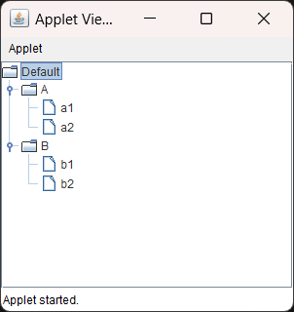

1. **Write a program code to generate the following output**

**Program:**

import java.awt.*;

import javax.swing.*;

import javax.swing.tree.*;

import java.applet.*;

import javax.swing.JScrollPane;

public class pract7_X2 extends JApplet

{    public void init()

    {

        Container c = getContentPane();

        c.setLayout(new BorderLayout());

DefaultMutableTreeNode ind , mh, gj , mum,pune,nas,nag;

        ind = new DefaultMutableTreeNode("India");

        JTree t = new JTree(ind);

        mh = new DefaultMutableTreeNode("Maharashtra");

        gj = new DefaultMutableTreeNode("Gujarat");

        ind.add(mh);

        ind.add(gj);

        mum = new DefaultMutableTreeNode("Mumbai");

        mh.add(mum);

        pune = new DefaultMutableTreeNode("Pune");

        mh.add(pune);

        nas = new DefaultMutableTreeNode("Nashik");

        mh.add(nas);

        nag = new DefaultMutableTreeNode("Nagpur");

        mh.add(nag);

        int v = ScrollPaneConstants.VERTICAL_SCROLLBAR_ALWAYS;

        int h = ScrollPaneConstants.HORIZONTAL_SCROLLBAR_ALWAYS;

        JScrollPane jsp;

        jsp = new JScrollPane(t, v, h);

        c.add(jsp);

   }

}

/*

<applet code=pract7_X2.class width=300 height=300></applet>

*/

**Output:**

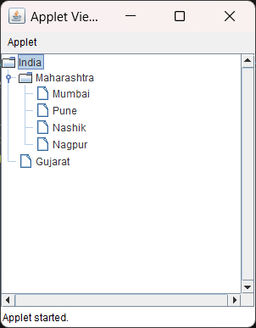

**Exercise: Write a JTree program to show root directory and its subfolder of your System.**

**Program:**

import java.awt.*;

import javax.swing.*;

import javax.swing.tree.*;

public class pract7_ex1 extends JApplet

{

    public void init()

    {

        Container c = getContentPane();

        c.setLayout(new BorderLayout());

        DefaultMutableTreeNode C , c1 , c2,c3,c4,c11,c12,c13,c14,c15,c21,c22,c23,c24,c25,c31,c32,c33,c34,c35;

        DefaultMutableTreeNode c41,c42,c43,c44,c45;

        C = new DefaultMutableTreeNode("Windows (C:)");

        JTree t = new JTree(C);

        c1 = new DefaultMutableTreeNode("Program Data");

        c2 = new DefaultMutableTreeNode("Program Files (x86)");

        c3 = new DefaultMutableTreeNode("Program Files");

        c4 = new DefaultMutableTreeNode("AMD");

        C.add(c1);

        C.add(c2);

        C.add(c3);

        C.add(c4);

        int v = ScrollPaneConstants.VERTICAL_SCROLLBAR_ALWAYS;

        int h = ScrollPaneConstants.HORIZONTAL_SCROLLBAR_ALWAYS;

        JScrollPane jsp = new JScrollPane(t , v, h);

        c.add(jsp);

        // c1

        c11 = new DefaultMutableTreeNode("Boost_interprocess");

        c12 = new DefaultMutableTreeNode("Express VPN");

        c13 = new DefaultMutableTreeNode("HP");

        c14 = new DefaultMutableTreeNode("McAfee");

        c15 = new DefaultMutableTreeNode("Microsoft OneDrive");

        c1.add(c11);

        c1.add(c12);

        c1.add(c13);

        c1.add(c14);

        c1.add(c15);

        // c2

        c21 = new DefaultMutableTreeNode("Common Files");

        c22 = new DefaultMutableTreeNode("Hewlett-Packard");

        c23 = new DefaultMutableTreeNode("Internet Explorer");

        c24 = new DefaultMutableTreeNode("Microsoft");

        c25 = new DefaultMutableTreeNode("MySQL");

        c2.add(c21);

        c2.add(c22);

        c2.add(c23);

        c2.add(c24);

        c2.add(c25);

        // c3

        c31 = new DefaultMutableTreeNode("WindowsPowerShell");

        c32 = new DefaultMutableTreeNode("Windows Mail");

        c33 = new DefaultMutableTreeNode("HPCommRecovery");

        c34 = new DefaultMutableTreeNode("Java");

        c35 = new DefaultMutableTreeNode("Microsoft Office 15");

        c3.add(c31);

        c3.add(c32);

        c3.add(c33);

        c3.add(c34);

        c3.add(c35);

        // c4

        c41 = new DefaultMutableTreeNode("CIM");

        c42 = new DefaultMutableTreeNode("CNext");

        c43 = new DefaultMutableTreeNode("InstallUEP");

        c44 = new DefaultMutableTreeNode("RyzenMasterSDK");

        c45 = new DefaultMutableTreeNode("WVR");

        c4.add(c41);

        c4.add(c42);

        c4.add(c43);

        c4.add(c44);

        c4.add(c45);

    }

}

/*<applet code=pract7_ex1.class width=400 height=520>

</applet>

*/

**Output:**

